**NIST: MBE samples B Al Ga In N**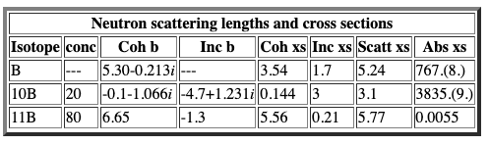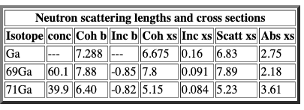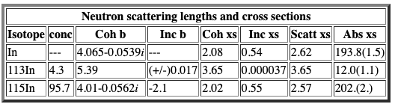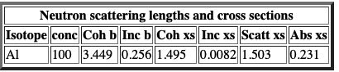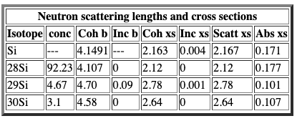

**Neutron Scattering length density (SLD) caculation**

|  |  |  |  |  |  |  |
| --- | --- | --- | --- | --- | --- | --- |
| Layer | Thickness(Å) | nSLDreal  (10-6 Å-2)  [[1]](https://www.ncnr.nist.gov/resources/activation/) | nSLDim (10-6 Å-2) | Density (g/cm3) [[2]](https://www.angstromsciences.com/density-elements-chart) | x-ray  SLDreal  (10-6 Å-2) | x-ray  SLDim (10-6 Å-2) |
| Pd | 13 | 4.02 | -0.001 | 12.02 | 20.858 | -0.096 |
| Al2O3 | 70.3 | 5.672 | 0 | 3.95 | 33.254 | -0.385 |
| V | 7.5 | -0.32 | -0.001 | 6.11 | 46.970 | -4.471 |
| Fe | 157 | 8.024 | -0.001 | 7.874 | 59.454 | -7.688 |
| VHx | 1100 | -0.6 |  |  |  |  |
| Fe | 157 | 8.024 | -0.001 | 7.874 | 59.454 | -7.688 |
| V | 7.5 | -0.32 | -0.001 | 6.11 | 46.970 | -4.471 |
| MgO | 104 | 6.014 | 0 | 3.6 | 30.668 | -0.326 |
| LiF | 104 | 2.301 | -0.012 | 2.635 | 20.818 | -0.095 |

[1]<https://www.ncnr.nist.gov/resources/activation/>

[2]<https://www.angstromsciences.com/density-elements-chart>

|  |  |  |  |  |
| --- | --- | --- | --- | --- |
| Layer | Thickness(Å) | SLDreal(10-6 Å-2) | SLDim(10-6 Å-2) | Density(g/cm3) |
| AlN | 13 | 6.135 | 0 | 3.26 |
| InN | 70.3 | 4.274 | -0.017 | 6.81 |
| GaN | 7.5 | 7.304 | -0.001 | 6.1 |
| InGaN | 157 |  |  |  |
| VHx | 1100 |  |  |  |
| Fe | 157 |  |  |  |
| V | 7.5 |  |  |  |
| LiF | 104 | 2.301 | -0.001 | 2.635 |
| Al2O3 | 70.3 | 5.672 | 0 | 3.95 |
|  |  |  |  |  |
|  |  |  |  |  |

